



HangOut Application

**CHANGE MANAGEMENT PLAN**

Version 1.0

Prepared by Mac & Cheese

Jethro Phuah An Ping

Lam Zhi Fah

Alicia Chua Jieying

Ernest Ang Cheng Han

Ong Jing Heng Shaun

Ong Sim Hao

Shannon Tan Xinyi

13 October 2021



**VERSION HISTORY**

| **Version #** | **Implemented By** | **Revision Date** | **Approved By** | **Approval Date** | **Reason** |
| --- | --- | --- | --- | --- | --- |
| 1.0 | *Shannon Tan Xinyi*  *Alicia Chua Jieying* | *13/10/2021* | *Jethro Phuah An Ping* | *15/10/2021* | *Initial Change Management Plan* |

**TABLE OF CONTENTS**

1. **INTRODUCTION 4**
   1. Purpose of The Change Management Plan 4
2. **CHANGE MANAGEMENT PROCESS 4**
   1. Change Request Process Flow Requirements 4
   2. Change Request Form and Change Management Log 5
   3. Evaluating and Authorizing Change Requests 5
      1. Change Control Board 7
3. **RESPONSIBILITIES 8**

**APPENDIX A: CHANGE MANAGEMENT PLAN APPROVAL 9**

**APPENDIX B: REFERENCES 10**

**APPENDIX C: KEY TERMS 11**

**APPENDIX D: CHANGE REQUEST FORM EXAMPLE 13**

**APPENDIX E: CHANGE MANAGEMENT LOG TEMPLATE 14**

# INTRODUCTION

## PURPOSE OF THE CHANGE MANAGEMENT PLAN

The Change Management Plan allows organizations to not only handle varying degrees of complex changes, but navigate changing landscapes as well. It contains the necessary information required to effectively manage project change from inception to delivery. With it, disruption to workflow can be avoided and the team can be properly supported through this change.

The Change Management Plan is created in the early stages of the project, more specially, the Planning Phase. Planning early will result in greater clarity and preparedness. Its intended audience is the project manager, project team, project sponsor and senior leaders whose support is needed to carry out the plan.

# CHANGE MANAGEMENT PROCESS

The Change Management process establishes an orderly and effective procedure for tracking the submission, coordination, review, evaluation, categorization and approval for release of all changes to the project’s baselines.

## CHANGE REQUEST PROCESS FLOW REQUIREMENTS

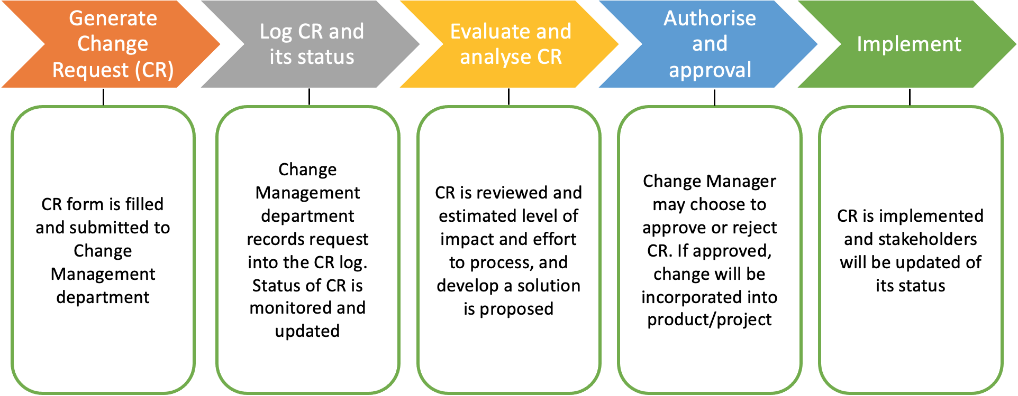

## CHANGE REQUEST FORM AND CHANGE MANAGEMENT LOG

Below is the description for the fields in the CR form:

| **Element** | **Description** |
| --- | --- |
| Date | Date CR was created |
| CR# | CR ID. Assigned by the Change Manager |
| Title | A brief description of the CR |
| Description | Description of the desired change. Impact, benefits and costs of a change should also be described |
| Submitter | Name of the person completing the CR Form and name of contact person (may be a different person from submitter) who can answer questions regarding the suggested change |
| Phone | Phone number of the submitter/contact person |
| E-Mail | Email of the submitter/contact person |
| Product | The product that the suggested change is for |
| Version | The product version that the suggested change is for |
| Priority | A code that provides a recommended categorization of the urgency of the requested change (Critical, High, Medium, Low, Insignificant) |

## 

## EVALUATING AND AUTHORIZING CHANGE REQUESTS

Change requests are evaluated using the following **priority criteria**:

| **Priority** | **Description** |
| --- | --- |
| Urgent | Any change that is urgently required by the client to be delivered first before the project can proceed/continue/resume or any significant issue that impacts the basic functionality of the product or have any financial impact. This CR needs to be resolved with immediate action as it is likely to impact all departments and all users. |
| High | Any change that affects important business processes/systems. This includes the need to overhaul project requirements and structure. This CR needs to be resolved as soon as possible as it will impact major users. |
| Medium | Any change that does not affect critical business processes and/or critical software components. Typically requested features made by the client. Such features are not rejectable. This CR causes little to no impact on the integrity and performance of the system. |
| Low | Minor problems or frontend change. Typically requested features made by the client. Such features are rejectable. This CR does not impact daily processes and/or for which a work around is available. |
| Mandatory | Additional features requested by the client. |

Change requests are evaluated and assigned one or more of the following **change types**:

| **Change Type** | **Impact of Change Type** |
| --- | --- |
| Scope | Change affecting scope of project |
| Duration | Change affecting duration/timeline of project |
| Cost | Change affecting cost of project |
| Resources | Change affecting resources needed for the project |
| Deliverables | Change affecting deliverables agreed for the project |
| Processes | Change affecting process of project |
| Quality | Change affecting quality of project |
| Availability | Change affecting the uptime of the application to the public domain |
| Reliability | Change affecting the integrity of the system |
| Scalability | Change affecting future enhancements |
| Maintainability | Change affecting efficiency and performance of operational status restoration |

Change requests are evaluated and assigned one of the following **status types**:

| **Status** | **Description** |
| --- | --- |
| Open | Entered/Open but not yet approved or assigned |
| Work in Progress | CR approved, assigned, and work is progressing |
| In Review | CR work is completed and in final review prior to testing |
| Testing | CR work has been reviewed and is being tested |
| Closed | CR work is complete, has passed all tests, and updates have been released |
| On Hold | CR approved, assigned, and work is put on hold |

## Change Control Board

| **Role** | **Name** | **Contact** | **Description** |
| --- | --- | --- | --- |
| Project Manager | Jethro Phuah An Ping | + 65 8888 8888 | Oversees project progress.  Approves and executes project plan  Reviews and approves any other relevant documents |
| Risk Manager | Lam Zhi Fah | +65 8128 9025 | Ensure all risk project plans changes are implemented and reinforced  Established strategies to minimize and eliminate risk |
| Client Representative | Alicia Chua Jieying | +65 9888 8585 | Procure and recommend potential products or services to management  Keep and maintain process user accounts  Resolve customer complaints/queries via phone.  Under client’s concerns and relay it to the team |
| Finance Manager | Shannon Tan Xinyi | + 65 9781 2345 | Monitoring cash flow  Ensure that business meets all its statutory and compliance obligations, including statutory accounting and tax issues  Keep track of current market trends  Propose cost-efficient alternatives whenever possible |
| Test Manager | Ong Sim Hao | +65 9182 1361 | Ensure all testing adhere to software functional requirements  Designs testing strategies and test cases  Executes test procedures  Oversee testing team |
| Development Manager | Ernest Ang Cheng Han | + 65 8101 1234 | Establish and stimulate software development standards and processes along with best practices for delivery of scalable and high-quality software  Oversees the development team |
| Assistant Development Manager | Ong Jing Heng Shaun | +65 9867 1234 | Ensure that change requests are understood by the development team  Ensure that change requests are able to be developed in time |

# RESPONSIBILITIES

| **Role** | **Name** | **Contact** | **Description** |
| --- | --- | --- | --- |
| Project Manager | Jethro Phuah An Ping | + 65 8888 8888 | Oversees team’s performance and progress  Ensure proper time management  Review and approves project documents  Ensure effective implementation and development of project |
| Change Manager | Ong Jing Heng Shaun | +65 8128 9025 | Lead change management activities  Strategise by using change management process and tools to support development of  changes to be adopted by the project |
| Change Analyst | Ernest Ang Cheng Han | +65 9888 8585 | Analyse statistics on changes and the impact of the changes  Define and propose change management activities  Assist Change Manager in evaluating proposed changes |
| Ong Sim Hao | + 65 9781 2345 |
| Change Agent (Communication) | Alicia Chua Jieying | +65 9182 1361 | Ensure that change related information are communicated clearly among all stakeholders  Develop effective communication channels to encourage efficient interactions between stakeholders |
| Change Agent (Human Resource) | Shannon Tan Xinyi | + 65 8101 1234 | Provide HR support on employee-related changes  Advise on HR infrastructure for change management office and change control board |
| Executive Project Sponsor | Lam Zhi Fah | +65 9867 1234 | Oversee entire project lifecycle  Focus on strategies for more efficient and effective implementation |

# Appendix A: Change Management Plan Approval

The undersigned acknowledge they have reviewed the Hangout **Change Management Plan** and agree with the approach it presents. Changes to this **Change Management Plan** will be coordinated with and approved by the undersigned or their designated representatives.

Signature: JPHUAH Date: 13/10/2021

| Print Name: | Jethro Phuah An Ping |  | |
| --- | --- | --- | --- |
| Title: | Project Manager |
| Role: | Oversees the management of the team |
| Signature: | ErnestACH | Date: | 13/10/2021 |
| Print Name: | Ernest Ang Cheng Han |  |  |
| Title: | Development Manager |  |  |
| Role: | Lead teams of software developers |  |  |
| Signature: | Zhi | Date: | 13/10/2021 |
| Print Name: | Lam Zhi Fah |  |  |
| Title: | Change Manager |  |  |
| Role: | Monitors and supervises the process of operational changes |  |  |

# Appendix B: References

The following table summarizes the documents referenced in this document.

| **Document Name and Version** | **Description** | **Location** |
| --- | --- | --- |
| Hangout_Change_Management_Plan | Change Management Plan | Lab 4 -> Hangout_Change_Management_Plan |

# Appendix C: Key Terms

The following table provides definitions for terms relevant to this document. The terms are listed in ascending alphabetical order.

| **Term** | **Definition** |
| --- | --- |
| Authorize | Official permission to access a specific system or to carry out a specific function/task/change. |
| Baseline | An intermediate status of work results that record/save and approve at certain points in time. It serves to provide a fixed reference point for change management. |
| Change Control Board | A committee that reviews, evaluates and prioritizes change requests in the context of projects. |
| Change Management | A project management plan that has authority to approve or reject the changes on the project. |
| Change Request (CR) | A formal proposal for an alteration to the system. Such requests can originate from bugs / system enhancement / development of other systems / changes in underlying structure and or standards. |
| Change Request Form (CRF) | A form that is used to request an alteration in the project. |
| Deliverable | Any unique and verifiable product, result, or capability to perform a service that must be produced to complete a process, phase, or project. |
| Project Manager | The person in overall charge of the planning and execution of a project. |
| Quality | An interpretation which defines superiority and inferiority of things. It gives products’ sustainability, maintainability, and reliability. |
| Risk Management | A methodology or a mechanism, carried out throughout the development process to identify, manage and control risks evolved before and during the development process. |
| Stakeholder | A person, group or company that is directly or indirectly involved in the project and who may affect or get affected by the outcome of the project. |

# Appendix D: Change Request Form Example

Below is an example of a Change Request From which can be used to submit changes during the life of the project.

Link to form: [Change Request Form.docx](https://docs.google.com/document/d/1BOGIbUs-WkFlZ3NQTuTQQDyKifzib4SE/edit?usp=sharing&ouid=106342154695843875731&rtpof=true&sd=true)

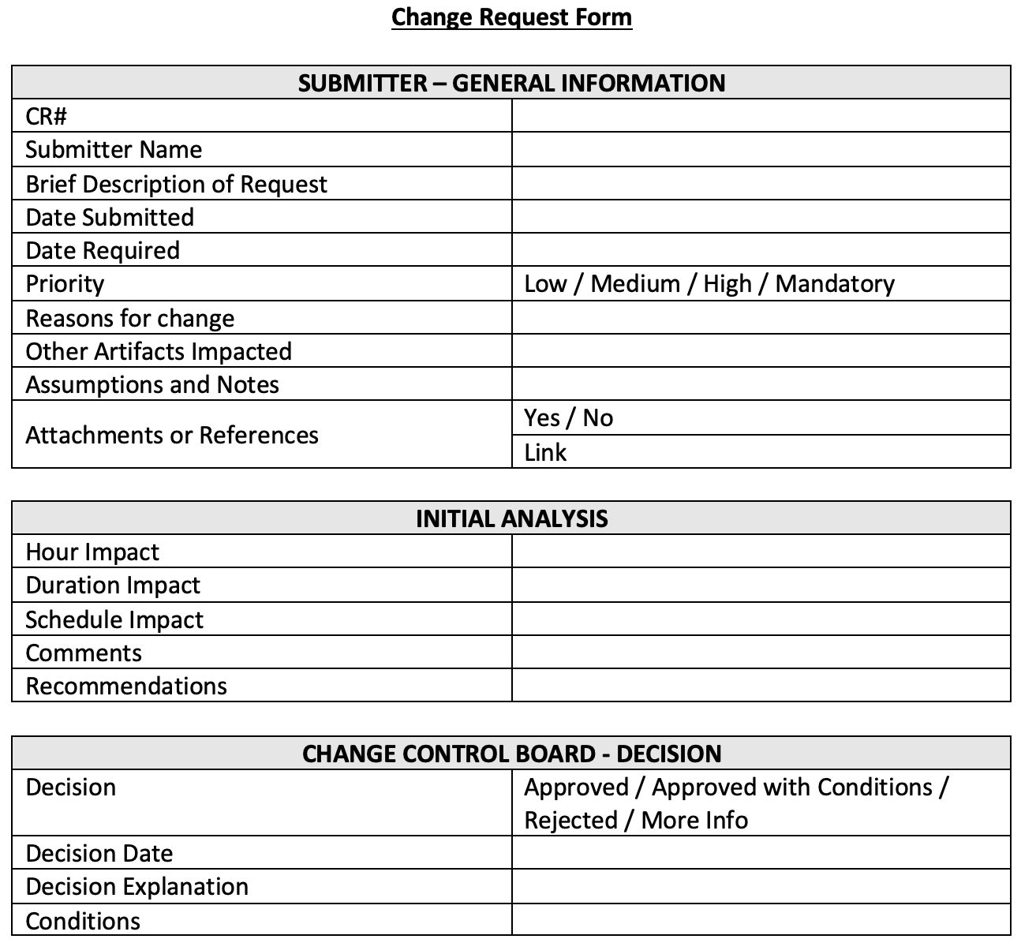

# Appendix E: Change Management Log Template

Below is an example of a Change Management Log template which can be used to track and manage requested changes during the life of the project.

Link to form: [Change Log.xlsx](https://docs.google.com/spreadsheets/d/1uKk9EgMviWhksdYEaLR2p1SOh1IrGQmD/edit?usp=sharing&ouid=106342154695843875731&rtpof=true&sd=true)

